Integration of BI into a Farming Company

Colorado State University, Global Campus

David Reese

For this assignment we are asked to create a system to help a large farming company create an inventory tracking system that will make it easier to track all aspects of the business. We need to track sales, shipping, orders and delivery to clients. We need to track the item from the field to the customer’s table, taking into account all the stops on the way.

This is a perfect application for radio frequency identification, or RFID tagging. The easy way to describe an RFID tag is to look at it like a small computer. So small it holds only 1 program. RFID tags have 3 distinct styles. First is the active which incorporates a microchip, radio transceiver antenna and battery. Second is the passive type which does not have the battery. It draws the power it needs from the reader/scanner. The semi passive system has a battery and will broadcast a short distance drawing power from the reader/scanner.

For this, I think a passive RFID tag is our best solution for the farm. Passive tags cost ranges from “seven and 20 cents depending on the data storage type and job requirements” (Bonsor, Fenlon, 11/07). Storage type is going to be where the bulk of the cost for this system will come from.

The data storage for RFID tags breaks into 3 types. First is the read-write type which allows for data to be added as well as overwritten. Read only means just that- no changes once the data tag is set in place. For this type of job, we need to use the WORM type of memory. Write once read many, or WORM tags “can have additional data added, but they cannot be overwritten” (Bonsor,Fenlon). We will be adding data to the tag as it goes through our warehouses to the end customers. This data will be captured and stored in the databases in the diagram for use by the farm staff.

The benefits of RFID as opposed to a barcode are many. First and foremost, we can “store large amounts of data to a unique identifier” (Kaur et.al 2/2011). Secondly the scanner does not have to be in the line of sight of the RFID tag the way a barcode does, nor does it require a human to go and read it. It can be scanned by machines on a production or sorting line. RFID tags are also more robust and can work in dirty environments and even in water. Good for a farm where a barcode might get damaged and become unreadable.

Drawbacks for barcodes are the cost. Compared to other systems RFID tag systems are “typically more expensive to set up and use than alternative systems such as optical scanning” (Finch, Techwalla). A potentially big drawback is interference. Since this is a radio, and the power to run the tag is supplied via electromagnetic current, things like walkie talkies, mobile phone towers and even forklifts can cause the system to have issues. Data Security can be compromised due the radio frequency getting hacked. “Side Channel attacks can pick up RFID data as it passes from a tag to a reader, which could give the attacker access to passwords or information” ( Finch) This concern is mitigated by the presence of data security in the system. RFID tags are still better than a printed barcode which could be easily copied.

In the diagram you can see how data from the field is first put onto a tag as harvest takes place. Receiving brings the inventory in and the tag is updated. Example: You take a flat of strawberries weighing 25 pounds and break it down into 50 half pound tubs. The tag at that point would include the field information, as well as the date the fruit was moved from a flat to individual tubs. When the fruit is pulled for an order, the ship date, and shipped to location information is added. That data is then added into the databases for the company.

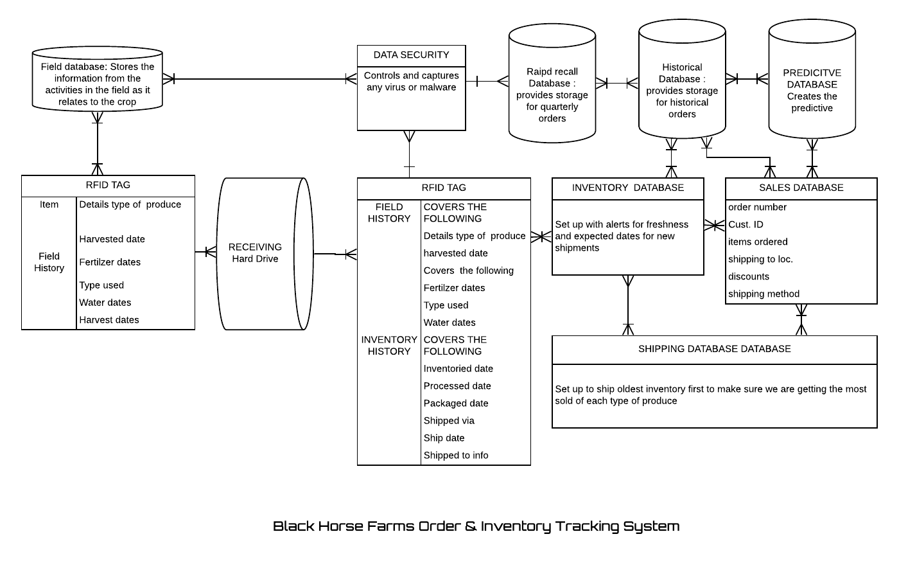

References

Kevin Bonsor & [Wesley Fenlon](https://www.howstuffworks.com/hsw-contact.htm) "How RFID Works" 5 November 2007.  
HowStuffWorks.com. <https://electronics.howstuffworks.com/gadgets/high-tech-gadgets/rfid.htm> 22 February 2020

Mandeep Kaur, Manjeet Sandhu, Neeraj Mohan and Parvinder S. Sandhu <https://pdfs.semanticscholar.org/5571/64fee5bd2d0a7add956de25d2ab2124fece7.pdf> International Journal of Computer and Electrical Engineering, Vol.3, No.1, February, 2011 1793-8163

Retrieved from techwalla <https://www.techwalla.com/articles/advantages-disadvantages-of-rfid> Carol Finch